1. To create a Clone of the master repo:

In Test complete: Create a Project and go to source control and select Clone repository.

And Select Source Path as : <https://ghe.coxautoinc.com/EP-OracleFinancials/cf-automation>

And Destination Path as: The Local Directory where it needs to be Cloned.

In the source path after https:// enter the code fd2c9b340f07b13234e709758adf55781a025314

[https:// fd2c9b340f07b13234e709758adf55781a025314@](https:// fd2c9b340f07b13234e709758adf55781a025314@ghe.coxautoinc.com/EP-OracleFinancials/cf-automation)

[ghe.coxautoinc.com/EP-OracleFinancials/cf-automation](https:// fd2c9b340f07b13234e709758adf55781a025314@ghe.coxautoinc.com/EP-OracleFinancials/cf-automation)

1. Your GIT account should have the token generated.

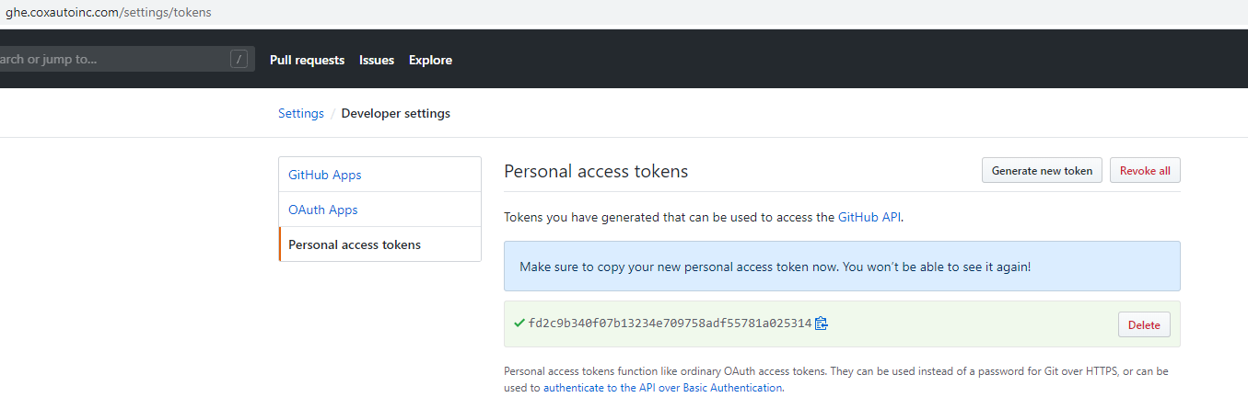

1. If the clone is not working and showing below error:

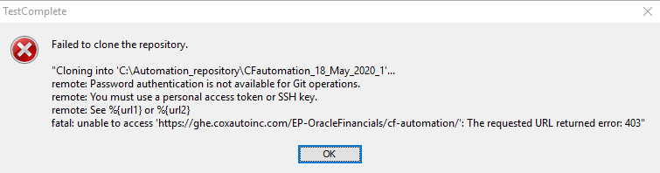

1. Go to Control Panel -> Credential Manager and Click on GIT and copy, paste the token generated in Step 2, here.

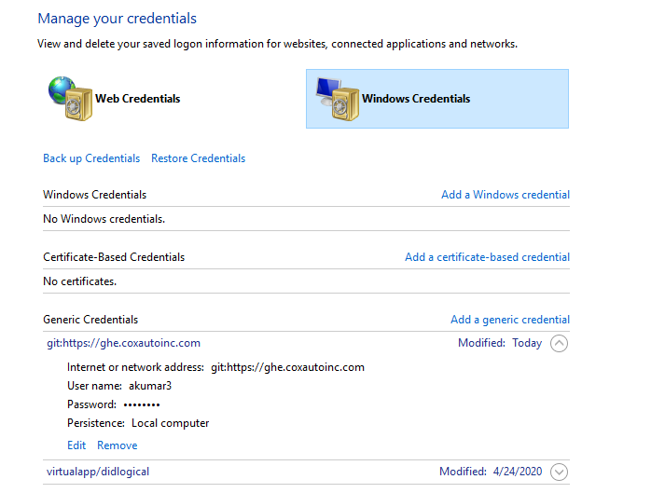

1. Try again Cloning, It should work.

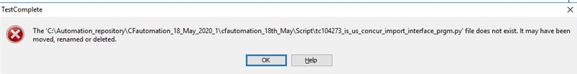

If you get an error message like the previously added files by some other persons are showing as file doesn’t exist then pull the request from the Master Branch with the option Merge. (In the left side, drop down)

TO Add the scenario Excel or Data file to the Branch .

1. go to source control, click add
2. select, include ignored files check box
3. commit and need to push it

To Create a Fresh Branch / Latest Branch.

1. Go to Switch / Checkout and change the Branch to Master.
2. The Local copy will get refreshed and reloaded as in Master.
3. Now go to Switch / Check out and Create a New Branch and click Ok.
4. The Branch Arun-Q3_S4 will get Created and will not be seen in GIT, unless you do a Commit and Push.